Q5)Ansible

1)create ineventory.ini file

2)create directory site_content for web content  


3)create playbook webserver.yml

4)Run the playbook

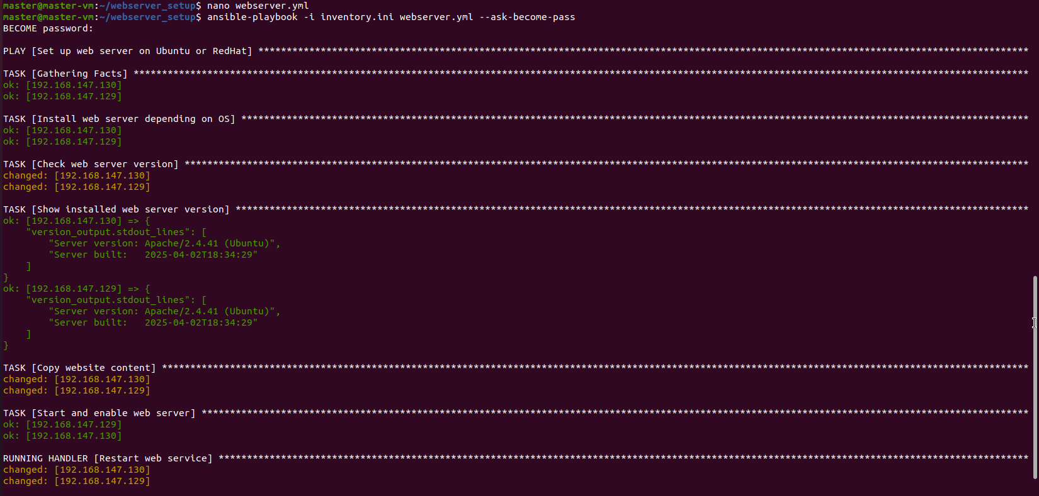

5)Then verify

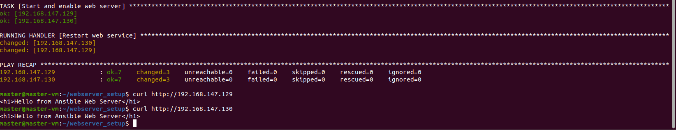

Output

